**Linear “OLS” Regression**

**Hand Calculations (20 POINTS):**

Run the following SAS program:

**data** TEMPFILE;

label Y = "Monthly use of steam (in pounds)";

label X8 = "Average temperature (F)";

input Y X8;

cards;

10.98 35.3

11.13 29.7

12.51 30.8

8.4 58.8

9.27 61.4

8.73 71.3

6.36 74.4

8.5 76.7

7.82 70.7

9.14 57.5

8.24 46.4

12.19 28.9

11.88 28.1

9.57 39.1

10.94 46.8

9.58 48.5

10.09 59.3

8.11 70

6.83 70

8.88 74.5

7.68 72.1

8.47 58.1

8.86 44.6

10.36 33.4

11.08 28.6

;

run;

**proc** **reg** data=TEMPFILE;

model Y = X8;

**run**;

**quit**;

The following output should be generated from the SAS code:

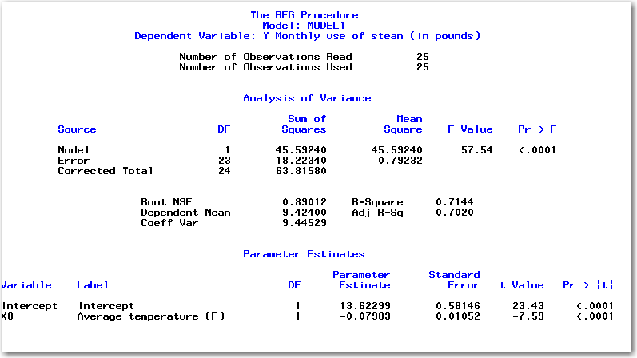

Using the above data, calculate all of the numbers in this table **BY HAND**. In other words, apply the regression formulas given in the text to generate the regression parameters and ANOVA table values given above. Here are the rules:

* Once you calculate a number, let me know where it is on the above table (i.e. this is the INTERCEPT PARAMETER ESTIMATE). If it’s easier for me to follow, then you will get more points!
* If a value is calculated from a table, tell me where you got the value (i.e. “page xxx from the text book”, “internet web site that has F tables”, “Excel”, etc.)
* I plan to spend 5 minutes each on this bonus problem. If I can’t find your answers (to my satisfaction) in that brief amount of time, you won’t get the points.
* I will give partial credit, so get as many points as you can.
* Grading extra work like this is time consuming. I don’t have time to go back and give you points that I overlooked the first time. Make it clear where everything is!
* In other words: **ALL SALES ARE FINAL !** ☺